DIS-Points-Benton-5000 to 3500 BCE

**Benton [Notched/Stemmed] Point. Dover chert., Boone County, Indiana**

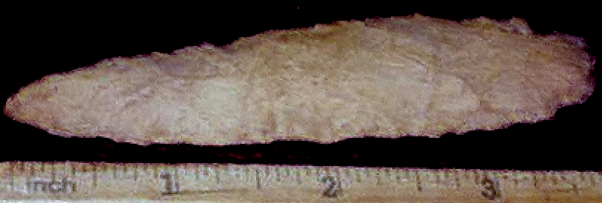

**Named by Madeline Kneberg in 1956. It is a medium-to-large point with a narrow blade and concave base. Shoulders are never barbed. Type dates to 5000- 3500 BCE and is found in the Gulf states. Justice (1987) suggests: the presence of oblique parallel flaking: edge beveling of the base and notch, and sometimes of the blade, is also a distinctive feature of the type,**

**Major attribute: size and flute flaking. short stem.**

**Type validity: traditional/classic.**

**Comment: Type has extensive variations and other than size, difficult to identify archaeologically, and is probably a time-marker, but needs nomenclature refining.**

**References:**

**Hranicky, Wm Jack. 2003. *Prehistoric Projectile Points Found Along the Atlantic Coastal Plain*. Coco Beach, FL.: Universal Publishers.**

**Elder, Robert. 1970. The Benton Points, *The Redskin*, 5:3, 70-71.**

**Johnson, Jay K., and Samuel O. Brookes. 1989. Benton Points, Turkey Tails, and Cache Blades: Middle Archaic Exchange in the Mid-south. *Southeastern Archaeology*, 8(2):134-145.**

**Justice, Noel D. 1987. *Stone Age Spear and Arrow Points of the Mid-continental and Eastern United States.* Bloomington: Indiana University Press.**

**Kneberg, Madeline. 1956. Some Important Projectile Point Types Found in the Tennessee Area. *Tennessee Archaeologist*, XII:1, 25.**

**Meeks, Scott C. 2000. *The Use and Function of Late Middle Archaic Projectile Points in the Mid-south.* Moundville Archaeological Park, Moundville: University of Alabama Museums.**

**Sherwood, Sarah C., Boyce N. Driskell, Asa R. Randall, and Scott C. Meeks. 2004. Chronology and Stratigraphy at Dust Cave, Alabama. *American***

***Antiquity*, 69:3, 533-554.**